Development of control strategies for earthquake reproduction on shaking table

Afonso Henrique
Earthquake Engineering and Structural Dynamics Unit (NESDE/DE)
Laboratório Nacional de Engenharia Civil (LNEC)
Lisbon, Portugal
ahenrique@lnec.pt
Miguel Ayala Botto
IDMEC, Instituto Superior Técnico, Universidade de Lisboa, Portugal
ayalabotto@tecnico.ulisboa.pt
Fernando Oliveira
Modelling and Rock Mechanics Unit (NMMR/DBB)
Laboratório Nacional de Engenharia Civil (LNEC)
Lisbon, Portugal
fvoliveira@lnec.pt

Abstract—On this communication a new methodology is proposed for controlling shaking table systems in reproducing earthquakes. The system is identified online (closed‑loop) using the two‑stage method, and the controller is synthesized through an optimization algorithm that minimizes the squared error between the target and output response spectra. The validation of this methodology is achieved on a small-scale shaking table whose PIDF and LQI optimal controllers are used to evaluate the system performance. Numerical simulations using the identified physical model subjected to eight earthquakes show that both controllers outperform the OLI strategy currently used at LNEC, with the LQI controller achieving the best system performance. These findings partially validate the effectiveness of the proposed methodology, whose physical implementation will be carried out to confirm its performance on the experimental system.
Keywords— Earthquake Engineering, Control Systems, Closed-loop Identification,

Introduction
Earthquakes are among the most catastrophic natural events, frequently causing severe loss of life, extensive property damage, and significant socio‑economic disruption. One of the most effective ways to reduce seismic risk is by decreasing the structural vulnerability of the built environment, which can be assessed through experimental techniques such as shaking‑table testing.
Shaking‑table tests consist of mounting a physical model on a stiff platform that is driven so as to reproduce the desired ground‑motion time history (reference signal). This experimental technique was introduced in the 1940s and became widespread during the 1960s. Early systems relied on mechanical profiled cams to generate the excitation, but servo‑hydraulic systems soon became the standard solution ([1],[2],[3]). At the Laboratório Nacional de Engenharia Civil (LNEC) a Goodmans model VG-108 electrodynamic shaker attached to a movable table was installed in the 60s to perform seismic tests [4]. a uniaxial shaking table (ST1D) was developed and installed, consisting of a 3 m × 2 m horizontal steel platform and a vertical platform body driven by a hydraulic actuator supplied by a dedicated oil‑hydraulic circuit ([5], [6]). During this period, adaptive control strategies were developed, implemented, and validated both on a small‑scale shaking table and on the ST1D, for tracking reference earthquake spectrum (frequency domain), iteratively ([8],[9]). Increasingly demanding requirements for reproducing seismic excitation along all three directions motivated the development of the triaxial shaking table ST3D, which has been installed and operational at LNEC since the mid‑1990s [4]. The reproduction of earthquakes on a shaking table depends strongly on: i) the hardware (mechanical and electrical system), which usually has limitations and therefore can distort the reference signal and; ii) the control system, whose performance is highly sensitive to the adopted control strategy and tuning. The hydraulic and control system supplier, MTS Systems Corporation (MTS) provided several control strategies: i) Three-Variable Control (TVC), also known in control theory literature as state variable control [9], which combines the displacement, velocity and acceleration feedback [1]; ii) Adaptive Harmonic Cancellation (AHC), suitable for sinusoidal signals (fixed frequency or sweep); iii) Adaptive Inverse Control (AIC) [10], suitable for non-sinusoidal signals on linear systems; iv) Amplitude/Phase Control (APC), suitable for sinusoidal signals (fixed frequency and sweep) and predominantly linear systems, and often used in conjunction with AHC to reduce distortions in nonlinear systems; v) Online Iteration (OLI), suitable for nonlinear systems and non-sinusoidal waveforms. This last strategy is the most appropriate for earthquake engineering applications, as structures may exhibit nonlinear behaviour or sustain damage during testing. OLI is currently the control method implemented at LNEC’s ST3D.
Shaking‑table control strategies typically begin with the offline generation of a drive signal using the inverse model of the system and the desired reference motion. This drive signal is then applied to the system, which usually incorporates a linear controller, most commonly a Proportional‑Integral‑Derivative (PID) controller, using actuator feedback signals (displacement, velocity, or acceleration) [1]. This is the basis of the OLI control strategy. Indeed, PID controllers remain widely used in most test systems, including shaking‑table and hybrid testing platforms[11]. Alternative control approaches have been proposed in the literature, including: i) Acceleration Trajectory Tracking Control (ATTC); ii) displacement feedforward-feedback controller using an optimal controller; iii) Model-based feedforward-feedback controller for acceleration tracking [11]; iii) minimal control synthesis (MCS) strategy, which is feedback-feedforward adaptive control strategy including the inverse model in line with the reference signal [1].
Returning to the OLI strategy currently implemented at LNEC’s shaking table, several limitations can be identified: i) the PID controller parameters are fixed and cannot be adapted to the device under test or to the characteristics of the reference signal; ii) the approach requires the offline computation of the drive signal to be fed into the system; iii) the procedure is iterative, often requiring multiple drive‑signal updates to achieve the target response, which increases testing time and may induce additional damage to the specimen. This work presents an alternative control methodology for shaking‑table testing. The system is identified in closed-loop using the two‑stage method, then an optimized controller tune is synthesized for the identified model and the target earthquake signal through the Nelder-Mead simplex optimization algorithm, which minimizes the mean squared error between the target and output response spectra. The best controller obtained from this process is then selected for implementation. Eight earthquake records were considered to evaluate the performance of the proposed methodology on a small‑scale shaking table equipped with both a PIDF and an optimal LQI controller. Numerical simulations based on the identified physical model demonstrate that these two strategies outperform the OLI control approach currently used at LNEC, with the LQI controller exhibiting the best performance. These results partially validate effectiveness of the proposed methodology and confirm the previous results obtained with the numerical model of the ST1D shaking table [12]. The physical implementation of the controller will be carried out in the near future to fully confirm and validate the approach on the experimental system.

LNEC’s Shaking Table Test process & Control system
The current control strategy implemented in the LNEC shaking table tests is based on the OLI algorithm (). It involves the iterative synthesis of a drive signal with progressively increasing severity, aiming to ensure that the platform accurately reproduces the response spectra of the reference signal, i.e., the target earthquake.
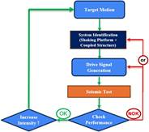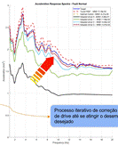
- LNEC’s seismic test process ilustrating the drive generation computation.
The process consists in testing the structure to a series of test steps starting at a low severity earthquake (scaled earthquake) and then repeated with the same earthquake at higher severity (higher amplitude), and so on until a defined amplitude is reached, which usually corresponds to the original amplitude of the earthquake – reference severity. At each test step the structural damage es accessed and, before starting a test step, an identification of the system's transfer function is carried out, using a limited-band pink noise signal (slope of -10dB/decade). This function is then used in the command signal generation algorithm to generate the drive signal for each test step. Throughout this process, the amplitude of the reference signal increases progressively, and it is expected that the structure will enter a non-linear regime, either due to the behaviour of some of its components or the damage accumulated during the various tests. At each test step, the system's performance is evaluated by comparing the response spectrum of the reference signal with that of the signal measured on the platform. The response spectrum is a fundamental concept in earthquake engineering and structural dynamics, as it represents the maximum response (such as displacement, velocity, or acceleration) for each natural frequency of a single degree of freedom mass-spring-damper system subjected to the ground motion. It represents how structures respond to a specific earthquake ground-motion record and is used to characterize earthquake severity. Consequently, different earthquake time histories can correspond to the same response spectrum, meaning they have the same severity. However, it is not always possible to achieve satisfactory performance with the command signal synthesized initially, and it may be necessary to generate more than one command signal and carry out additional test steps. This procedure, although necessary to fit the spectrum, it induces additional damage to the structure. Additionally, physical limitations inherent to the equipment, namely with regard to the finite field of displacement, velocity and acceleration, must be duly considered during the tests.
Descrever a aplicação da mini mesa: mini mesa, instrumentação (sensores, condicionadores, controlador em tempo real, etc),

Methodology

Foreword
Introduzir a metodologia proposta que se descreve em detalhe nos subcapitulos seguintes: Model identification: 2 stage method, Controler synthesys, System performance evaluation: response spectra description; System Implementation

System identification
The shaking tables at LNEC operate under feedback control, with a proportional-integral (PI) controller computing a control action from the position tracking error. The imperative of running experiments under closed-loop control poses additional challenges for identifying the plant, so a two-stage [Van den Hof and Schrama (1993)] was implemented to improve on the closed-loop identification consistency problem. Firstly, to identify the sensitivity function S₀, a linear FIR model with 100 parameters was fitted wusing MATLAB’s polyest function (the number of parameters was chosen arbitrarily for this first stage). Then a Hammerstein-Wiener model was defined, using the previously identified FIR model as the linear block, and with the output nonlinearity equal to that of the physical system (saturation of the control action at known values), resulting in a more refined model for the sensitivity function. This function was then used to compute the noise-free control action u_{r}, from which (by being uncorrelated with the output) the plant can now be estimated without bias introduced by the controller.
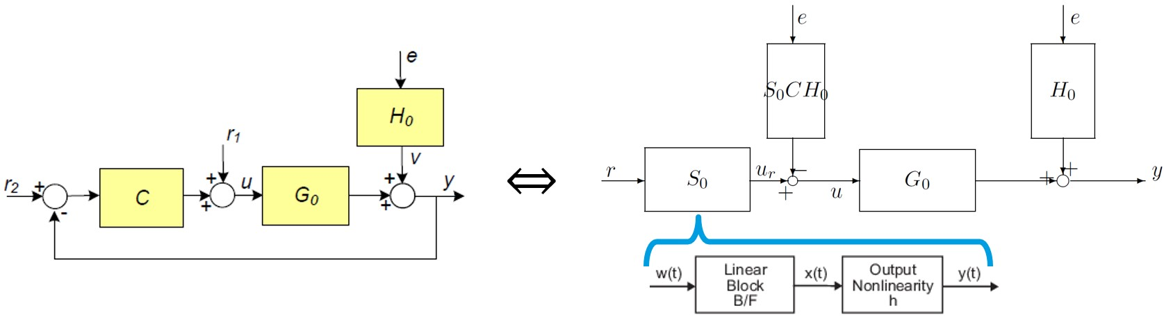

Control Strategies
LNEC’s driver signal iterative adaptation process: This control technique is known as Online Iteration (OLI) [MTS Systems], as it iteratively modifies the command input on an individual sample-by-sample basis until the system response is close to the target.

PIDF control strategy: Proportional-integral-derivative filtered controllers apply a control action which is the sum of three components: One proportional to the tracking error, another proportional to the integral of the error, and another proportional to a filtered derivative of the error, where the tuneable parameters are the gains K_{p} , K_{i} , K_{d}, and the filter term T_{f} :
$$C\left(z\right)=K_{p}+K_{i}\frac{T_{s}}{z-1}+K_{d}\frac{1}{T_{f}+\frac{T_{s}}{z-1}}$$
Taking into consideration the test procedure at LNEC [Fig. 1], where the identification is carried out each time the target signal is scaled up, or even additional times for various other reasons, one possible straightforward improvement would be to update the controller tune using this information. Another simple enhancement would be to add a filtered derivative term to the controller (making it a PIDF), since this should be of simple implementation in the existing version of the control software since it's just an extension of the existing controller structure. The optimized PIDF controller parameters were computed with MATLAB's pidtune function for the identified plant with the tuning option 'DesignFocus' set to 'reference-tracking’, and a target 0dB gain crossover frequency set such that the closed-loop gain at low frequency was approximately 0dB.
LQI control strategy: For the tracking loop shown in figure \ref{fig_LQI_loop}, where sys is a state space model of the plant, the optimal state feedback control law which minimizes the cost function $J\left(u\left(t\right)\right)=\sum_{0}^{∞}{x^{⊺}Q}x+u^{⊺}Ru dt$
was computed using MATLAB lqi function, with R=1, and a diagonal Q matrix optimized via Nelder-Mead simplex algorithm, using MATLAB’s fminsearch, to minimize the acceleration response spectrum MSE computed for 100 logarithmically spaced points between 0.1Hz and 30Hz.
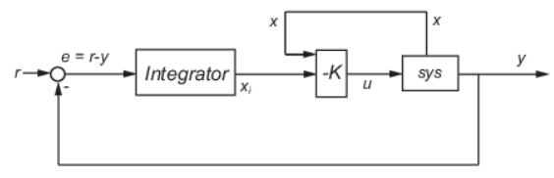

System performance evaluation: Response Spectrum
The performance of each control strategy was evaluated by acceleration and displacement response spectrum mean squared error (MSE). The acceleration response spectrum was computed from 0.1Hz to 30Hz for 500 logarithmically spaced points, and the displacement response spectrum was computed for the same frequencies, however, for only the first 344 points, equating to a range from 0.1Hz to 5.04Hz. The 1DOF mass spring damper system for which the response spectrum was computed consisted of a 1kg mass with a damping ratio ξ = 0.05, for which the spring stiffness and damping were computed to yield the desired natural frequency.

Results

Foreword

Input actions considered: scaled Earthquakes

Summary of results
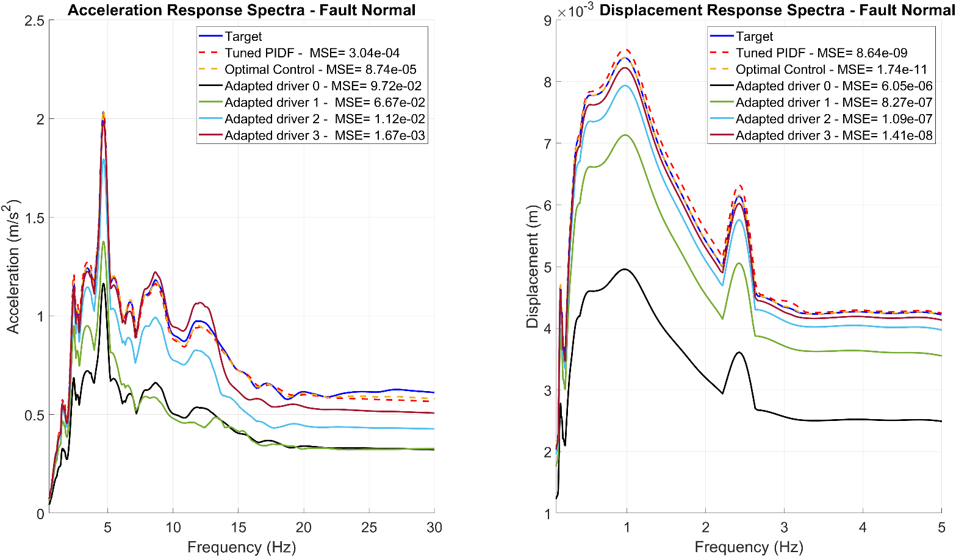
- Figura 1 Acceleration response spectrum MSE for various seismic signals

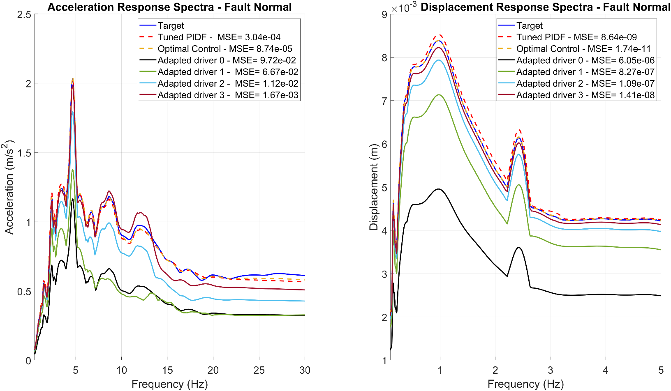

- Acceleration response spectrum MSE for various seismic signals

- Displacement response spectrum MSE for various seismic signals

Conclusions & Outlook
Adaptar aos resultados do shaker Regarding the analysis in sections \ref{sec_Tuned_PIDF} and \ref{sec_Optimal_Control}, optimal control results in a much more precise replication of the ground response spectra at low frequencies, unlike the tuned PIDF which exceeds the desired response spectra in the same band. However, the trade-off for this accuracy at lower frequencies is a response spectrum that falls short at higher ones. The optimal controller can be tuned for increasingly larger cut off frequencies without undesired amplification at low frequency, unlike the PIDF, but the results of this is practice may differ from the simulation studies preformed using the current model.

The results indicate that the tuned controllers (PIDF \& Optimal) offer superior performance in terms of response spectra compared to the adapted drivers, while also requiring less user intervention doing so, with optimal control providing the best results in every instance. However, both the performance of the controllers and the adapted drivers depends on identifying the system, and the sensitivity of each method to quality of the identification is still unknown.

Acknowledgment
The authors acknowledge LNEC for its financial support through the research fellowship under the LNEC Research Programme Modelação do Comportamento Estrutural- Mestr, and Fundação para a Ciência e a Tecnologia (FCT) for its financial support via LAETA (project https://doi.org/10.54499/UID/50022/2025).

References

- S. J. Chapman, M. S. Williams, A. Blakeborough, “Laboratory testing of structures under dynamic loads: an introductory review”. Philos Trans A Math Phys Eng Sci; 359 (1786): 1651–1669, 15 September 2001. https://doi.org/10.1098/rsta.2001.0860
- E. C. Carvalho, “Seismic Testing of Structures”, 11th European Conference os Earthquake Engineering, Balkema, Rotterdam, 1998.
- P. X. Candeias, A. A. Correia, G. G. Tekeste, “Shake Table Testing Techniques: Current Challenges and New Trends,” In: Chastre, C., Neves, J., Ribeiro, D., Neves, M.G., Faria, P. (eds) Advances on Testing and Experimentation in Civil Engineering. Springer Tracts in Civil Engineering . Springer, Cham. https://doi.org/10.1007/978-3-031-23888-8_8
- T. Emílio, R. T. Duarte, F. Carvalhal, C. O. Costa, C. T. Vaz, M. R. Corrêa, The new LNEC shaking table for earthquake resistance testing”, Memória 757, LNEC, Lisboa, 1989.
- R. Bairrão, Duque, Simulador Sísmico Uniaxial - Descrição e operação, Relatório LNEC, 94/1998 - C3ES/SES, LNEC, Lisboa, 1998.
- P. Castro, Mesa Vibratória Vertical (Projeto), Relatório LNEC, Obra 76/53/1077, LNEC, Lisboa, Junho de 1978.
- F. Carvalhal, Simulation of Seismic Distubances Using Adaptive Control, MSc Thesis, Victoria University of Manchester, Institute of Science and Technology, October of 1974.
- F. Carvalhal, Controlo Adaptativo na Simulação de Solicitações Sísmicas, Tese para Especialista LNEC, STG/DPA, Proc. 76/13/5588, Lisboa, Janeiro de 1979.
- K. Ogata, Modern Control Engineering. 5th Edition, Pearson, Upper Saddle River, 2010.
- B. Widrow, E. Walach, Adaptive Inverse Control: A Signal Processing Approach, Institute of Electrical and Electronic Engineers, 16 July 2007. DOI:10.1002/9780470231616
- G. G. Tekeste, Real-Time Hybrid Simulation including a Shaking Table – Development and Application to Soil-Structure Interaction. PhD Thesis. Univ. de Aveiro, 2021.
- A. Henrique, M. A. Botto, F. Oliveira, “Desenvolvimento de estratégias de controlo para reprodução de sismos em plataforma sísmica uniaxial,” 13º Congresso Nacional de Mecânica Experimental – CNME2026, Faculdade de Engenharia da Universidade do Porto, Porto, 25 a 27 de fevereiro de 2026.

ORIGINAL TEMPLATE

Abstract—This electronic document is a “live” template and already defines the components of your paper [title, text, heads, etc.] in its style sheet. *CRITICAL: Do Not Use Symbols, Special Characters, Footnotes, or Math in Paper Title or Abstract. (Abstract)
Keywords—component, formatting, style, styling, insert (key words)

Introduction (Heading 1)
This template, modified in MS Word 2007 and saved as a “Word 97-2003 Document” for the PC, provides authors with most of the formatting specifications needed for preparing electronic versions of their papers. All standard paper components have been specified for three reasons: (1) ease of use when formatting individual papers, (2) automatic compliance to electronic requirements that facilitate the concurrent or later production of electronic products, and (3) conformity of style throughout a conference proceedings. Margins, column widths, line spacing, and type styles are built-in; examples of the type styles are provided throughout this document and are identified in italic type, within parentheses, following the example. Some components, such as multi-leveled equations, graphics, and tables are not prescribed, although the various table text styles are provided. The formatter will need to create these components, incorporating the applicable criteria that follow.

Ease of Use

Selecting a Template (Heading 2)
First, confirm that you have the correct template for your paper size. This template has been tailored for output on the A4 paper size. If you are using US letter-sized paper, please close this file and download the Microsoft Word, Letter file.

Maintaining the Integrity of the Specifications
The template is used to format your paper and style the text. All margins, column widths, line spaces, and text fonts are prescribed; please do not alter them. You may note peculiarities. For example, the head margin in this template measures proportionately more than is customary. This measurement and others are deliberate, using specifications that anticipate your paper as one part of the entire proceedings, and not as an independent document. Please do not revise any of the current designations.

Prepare Your Paper Before Styling
Before you begin to format your paper, first write and save the content as a separate text file. Complete all content and organizational editing before formatting. Please note sections A-D below for more information on proofreading, spelling and grammar.
Keep your text and graphic files separate until after the text has been formatted and styled. Do not use hard tabs, and limit use of hard returns to only one return at the end of a paragraph. Do not add any kind of pagination anywhere in the paper. Do not number text heads-the template will do that for you.

Abbreviations and Acronyms
Define abbreviations and acronyms the first time they are used in the text, even after they have been defined in the abstract. Abbreviations such as IEEE, SI, MKS, CGS, sc, dc, and rms do not have to be defined. Do not use abbreviations in the title or heads unless they are unavoidable.

Units
- Use either SI (MKS) or CGS as primary units. (SI units are encouraged.) English units may be used as secondary units (in parentheses). An exception would be the use of English units as identifiers in trade, such as “3.5-inch disk drive”.
- Avoid combining SI and CGS units, such as current in amperes and magnetic field in oersteds. This often leads to confusion because equations do not balance dimensionally. If you must use mixed units, clearly state the units for each quantity that you use in an equation.
- Do not mix complete spellings and abbreviations of units: “Wb/m2” or “webers per square meter”, not “webers/m2”. Spell out units when they appear in text: “. . . a few henries”, not “. . . a few H”.
Identify applicable funding agency here. If none, delete this text box.
- Use a zero before decimal points: “0.25”, not “.25”. Use “cm3”, not “cc”. (bullet list)

Equations
The equations are an exception to the prescribed specifications of this template. You will need to determine whether or not your equation should be typed using either the Times New Roman or the Symbol font (please no other font). To create multileveled equations, it may be necessary to treat the equation as a graphic and insert it into the text after your paper is styled.
Number equations consecutively. Equation numbers, within parentheses, are to position flush right, as in (1), using a right tab stop. To make your equations more compact, you may use the solidus ( / ), the exp function, or appropriate exponents. Italicize Roman symbols for quantities and variables, but not Greek symbols. Use a long dash rather than a hyphen for a minus sign. Punctuate equations with commas or periods when they are part of a sentence, as in:
a  b    
Note that the equation is centered using a center tab stop. Be sure that the symbols in your equation have been defined before or immediately following the equation. Use “(1)”, not “Eq. (1)” or “equation (1)”, except at the beginning of a sentence: “Equation (1) is . . .”

Some Common Mistakes
- The word “data” is plural, not singular.
- The subscript for the permeability of vacuum μ₀, and other common scientific constants, is zero with subscript formatting, not a lowercase letter “o”.
- In American English, commas, semicolons, periods, question and exclamation marks are located within quotation marks only when a complete thought or name is cited, such as a title or full quotation. When quotation marks are used, instead of a bold or italic typeface, to highlight a word or phrase, punctuation should appear outside of the quotation marks. A parenthetical phrase or statement at the end of a sentence is punctuated outside of the closing parenthesis (like this). (A parenthetical sentence is punctuated within the parentheses.)
- A graph within a graph is an “inset”, not an “insert”. The word alternatively is preferred to the word “alternately” (unless you really mean something that alternates).
- Do not use the word “essentially” to mean “approximately” or “effectively”.
- In your paper title, if the words “that uses” can accurately replace the word “using”, capitalize the “u”; if not, keep using lower-cased.
- Be aware of the different meanings of the homophones “affect” and “effect”, “complement” and “compliment”, “discreet” and “discrete”, “principal” and “principle”.
- Do not confuse “imply” and “infer”.
- The prefix “non” is not a word; it should be joined to the word it modifies, usually without a hyphen.
- There is no period after the “et” in the Latin abbreviation “et al.”.
- The abbreviation “i.e.” means “that is”, and the abbreviation “e.g.” means “for example”.
An excellent style manual for science writers is [7].

Using the Template
After the text edit has been completed, the paper is ready for the template. Duplicate the template file by using the Save As command, and use the naming convention prescribed by your conference for the name of your paper. In this newly created file, highlight all of the contents and import your prepared text file. You are now ready to style your paper; use the scroll down window on the left of the MS Word Formatting toolbar.

Authors and Affiliations
The template is designed for, but not limited to, six authors. A minimum of one author is required for all conference articles. Author names should be listed starting from left to right and then moving down to the next line. This is the author sequence that will be used in future citations and by indexing services. Names should not be listed in columns nor group by affiliation. Please keep your affiliations as succinct as possible (for example, do not differentiate among departments of the same organization).

For papers with more than six authors: Add author names horizontally, moving to a third row if needed for more than 8 authors.

For papers with less than six authors: To change the default, adjust the template as follows.

Selection: Highlight all author and affiliation lines.

Change number of columns: Select the Columns icon from the MS Word Standard toolbar and then select the correct number of columns from the selection palette.

Deletion: Delete the author and affiliation lines for the extra authors.

Identify the Headings
Headings, or heads, are organizational devices that guide the reader through your paper. There are two types: component heads and text heads.
Component heads identify the different components of your paper and are not topically subordinate to each other. Examples include Acknowledgments and References and, for these, the correct style to use is “Heading 5”. Use “figure caption” for your Figure captions, and “table head” for your table title. Run-in heads, such as “Abstract”, will require you to apply a style (in this case, italic) in addition to the style provided by the drop down menu to differentiate the head from the text.
Text heads organize the topics on a relational, hierarchical basis. For example, the paper title is the primary text head because all subsequent material relates and elaborates on this one topic. If there are two or more sub-topics, the next level head (uppercase Roman numerals) should be used and, conversely, if there are not at least two sub-topics, then no subheads should be introduced. Styles named “Heading 1”, “Heading 2”, “Heading 3”, and “Heading 4” are prescribed.

Figures and Tables

Positioning Figures and Tables: Place figures and tables at the top and bottom of columns. Avoid placing them in the middle of columns. Large figures and tables may span across both columns. Figure captions should be below the figures; table heads should appear above the tables. Insert figures and tables after they are cited in the text. Use the abbreviation “Fig. 1”, even at the beginning of a sentence.
- Table Type Styles
Table Head | Table Column Head
 | Table column subhead | Subhead | Subhead
copy | More table copyª
- Sample of a Table footnote. (Table footnote)
- Example of a figure caption. (figure caption)
Figure Labels: Use 8 point Times New Roman for Figure labels. Use words rather than symbols or abbreviations when writing Figure axis labels to avoid confusing the reader. As an example, write the quantity “Magnetization”, or “Magnetization, M”, not just “M”. If including units in the label, present them within parentheses. Do not label axes only with units. In the example, write “Magnetization (A/m)” or “Magnetization {A[m(1)]}”, not just “A/m”. Do not label axes with a ratio of quantities and units. For example, write “Temperature (K)”, not “Temperature/K”.

Acknowledgment (Heading 5)
The preferred spelling of the word “acknowledgment” in America is without an “e” after the “g”. Avoid the stilted expression “one of us (R. B. G.) thanks ...”. Instead, try “R. B. G. thanks...”. Put sponsor acknowledgments in the unnumbered footnote on the first page.

References
The template will number citations consecutively within brackets [1]. The sentence punctuation follows the bracket [2]. Refer simply to the reference number, as in [3]—do not use “Ref. [3]” or “reference [3]” except at the beginning of a sentence: “Reference [3] was the first ...”
Number footnotes separately in superscripts. Place the actual footnote at the bottom of the column in which it was cited. Do not put footnotes in the abstract or reference list. Use letters for table footnotes.
Unless there are six authors or more give all authors’ names; do not use “et al.”. Papers that have not been published, even if they have been submitted for publication, should be cited as “unpublished” [4]. Papers that have been accepted for publication should be cited as “in press” [5]. Capitalize only the first word in a paper title, except for proper nouns and element symbols.
For papers published in translation journals, please give the English citation first, followed by the original foreign-language citation [6].

- G. Eason, B. Noble, and I. N. Sneddon, “On certain integrals of Lipschitz-Hankel type involving products of Bessel functions,” Phil. Trans. Roy. Soc. London, vol. A247, pp. 529–551, April 1955. (references)
- J. Clerk Maxwell, A Treatise on Electricity and Magnetism, 3rd ed., vol. 2. Oxford: Clarendon, 1892, pp.68–73.
- I. S. Jacobs and C. P. Bean, “Fine particles, thin films and exchange anisotropy,” in Magnetism, vol. III, G. T. Rado and H. Suhl, Eds. New York: Academic, 1963, pp. 271–350.
- K. Elissa, “Title of paper if known,” unpublished.
- R. Nicole, “Title of paper with only first word capitalized,” J. Name Stand. Abbrev., in press.
- Y. Yorozu, M. Hirano, K. Oka, and Y. Tagawa, “Electron spectroscopy studies on magneto-optical media and plastic substrate interface,” IEEE Transl. J. Magn. Japan, vol. 2, pp. 740–741, August 1987 [Digests 9th Annual Conf. Magnetics Japan, p. 301, 1982].
- M. Young, The Technical Writer’s Handbook. Mill Valley, CA: University Science, 1989.
- K. Eves and J. Valasek, “Adaptive control for singularly perturbed systems examples,” Code Ocean, Aug. 2023. [Online]. Available: https://codeocean.com/capsule/4989235/tree
- D. P. Kingma and M. Welling, “Auto-encoding variational Bayes,” 2013, arXiv:1312.6114. [Online]. Available: https://arxiv.org/abs/1312.6114
- S. Liu, “Wi-Fi Energy Detection Testbed (12MTC),” 2023, gitHub repository. [Online]. Available: https://github.com/liustone99/Wi-Fi-Energy-Detection-Testbed-12MTC
- “Treatment episode data set: discharges (TEDS-D): concatenated, 2006 to 2009.” U.S. Department of Health and Human Services, Substance Abuse and Mental Health Services Administration, Office of Applied Studies, August, 2013, DOI:10.3886/ICPSR30122.v2

IEEE conference templates contain guidance text for composing and formatting conference papers. Please ensure that all template text is removed from your conference paper prior to submission to the conference. Failure to remove template text from your paper may result in your paper not being published.

